1. Test your knowledge

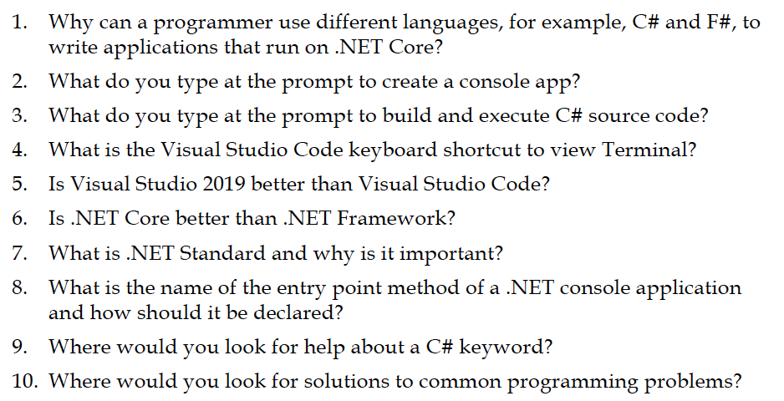

1. Check out what the code does in the console App?
   1. Code A
   2. Code B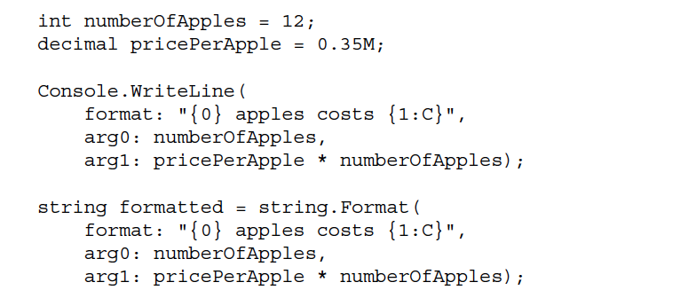

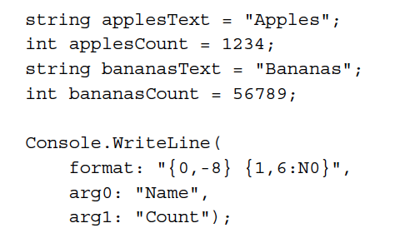

* 1. Code C

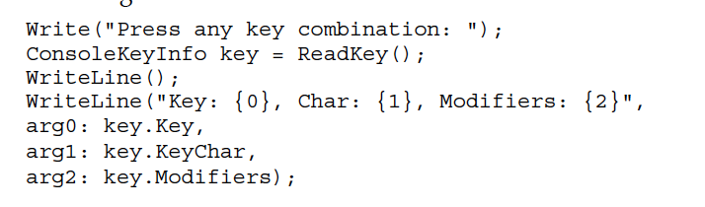

1. Follow instructions at

<https://docs.microsoft.com/en-us/dotnet/standard/base-types/composite-formatting>

and produce

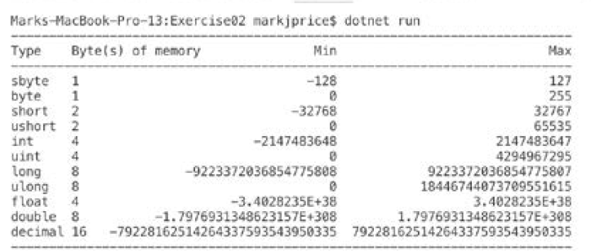

1. Work in pair and tell what the following IL codes do?
   1. Code fragment A

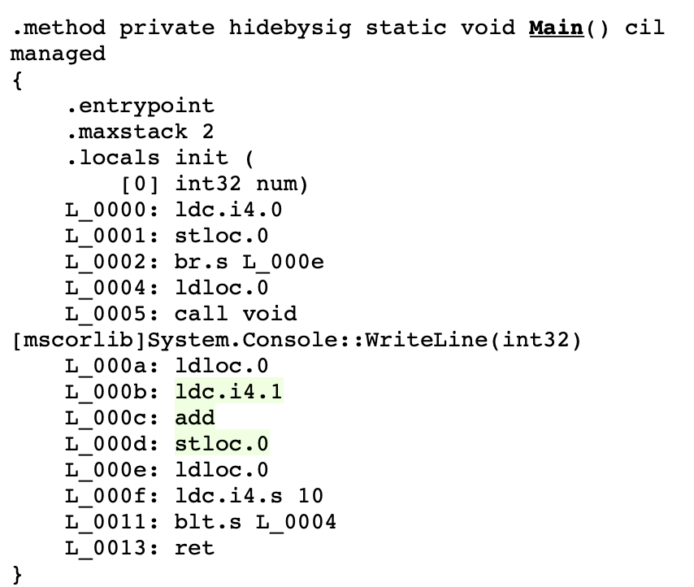

* 1. Code fragment B

